**Ordoñez, Juan Agustin**

**Rocamora, Eunace**

**BSIT MI 181**

**Wireframe, Mockup, & Prototype**

Image result for minesweeper bomb png black and white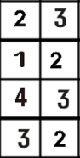Image result for minesweeper bomb png black and whiteImage result for minesweeper bomb png black and whiteImage result for minesweeper bomb png black and whiteImage result for minesweeper bomb png black and whiteImage result for minesweeper bomb png black and whiteImage result for minesweeper bomb png black and whiteImage result for minesweeper bomb png black and whiteImage result for minesweeper bomb png black and whiteImage result for minesweeper bomb png black and whiteImage result for minesweeper bomb png black and whiteImage result for minesweeper bomb png black and whiteImage result for minesweeper bomb png black and whiteImage result for minesweeper bomb png black and whiteImage result for minesweeper bomb png black and whiteImage result for minesweeper bomb png black and whiteImage result for minesweeper bomb png black and whiteImage result for minesweeper bomb png black and whiteImage result for minesweeper bomb png black and white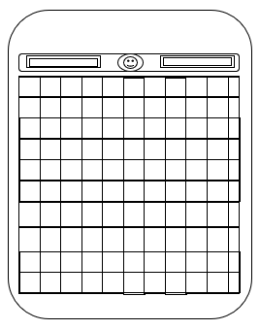Wireframe

YOU LOSE :<

View Highest Score

Load Saved Game

Start New Game

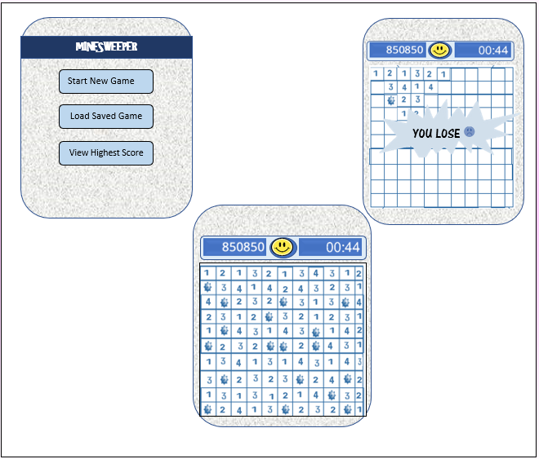Mockup

Prototype

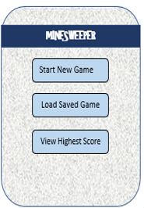

**Minesweeper** is a single-player puzzle video game. The objective of the game is to **clear a rectangular board containing hidden "mines" or bombs without detonating any of them.**

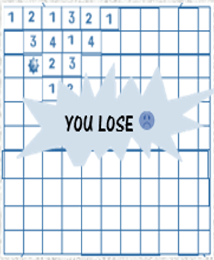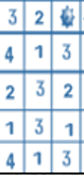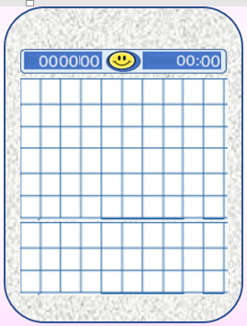0



**If the user tapped a box that contains a bomb, it will produce a pop-up message stating “You Lose” and if the user taps the okay button it will go back to the main screen.**

**Score**

**User**

**Time**

**When the user click the start new game, the game will start that will produce the following screen..**

**If the user tapped “Load Saved Game”, it will just load the ‘left’ game of the user.**

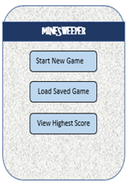

**Best Miner’s Score:**

**If the user tapped “View Highest Score”, it will produce the highest score that is saved in the application.**

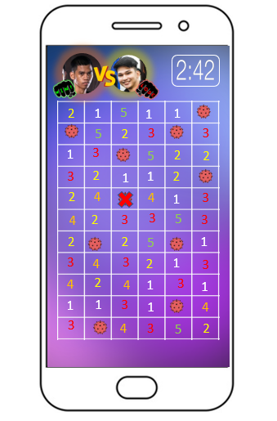Additional Feature

The mechanics of this game feature is that the very first one player who will pop a bomb will be declared as the loser and the other one is the winner

The additional feature of the application is the 2 players feature but the design of overall application is the same and the 2 players feature is the only thing that change.